# ABC Inventory Management

# Test Scenario: Login/Logout Scenario

# Scenario Description

This scenario is intended to test the Login and Logout functionality of the system. In this scenario a staff from a particular location logs in using their username and password. This is then followed by them logging out of the system. This is an important functionality as this covers the security requirement of the system. Moreover, this is the gateway to the rest of the functionality of the system.

# Version Control

|  |  |  |  |
| --- | --- | --- | --- |
| Version Number | Date | Author | Description |
| 5.0 | 13/09/2018 | Shirish Maharjan | Initial Draft |
| 5.1 | 14/09/2018 | Shirish Maharjan | First Version (Iteration 5) |

# Test Scripts

The following are the test scripts that will cover this scenario:

* LIS001 Login Script
* LOS001 Logout Script

# Use Case

The use case covered by this test scenario is as follows:

* Login/Logout

# Test Components/ Requirements

This test scenario covers the following high-level testing requirements:

* Test the Login functionality of the system.
* Test the Logout functionality of the system.

Specific requirements will be covered in each test scripts provided below

# User Groups

* Staff (User)

# Test Scripts

The following are the elaboration of the test scripts mentioned above:

# LIS001: Login Script

## Script Description

This script follows each step while logging in into the system to access the rest of the functionality of the system. This script will check if each step while logging in into the system is a success. If any step fails to succeed, a bug will be reported, and the test will be conducted again.

## Testing Requirements

This test will cover the login functionality of the system.

## Setup

* The computer in the location is powered on.
* Make sure the computer is connected to the internet.
* Application is launched.
* Username and password are known.

## Teardown

* User can use other functionalities as per their restrictions.

## Script Steps

|  |  |  |  |
| --- | --- | --- | --- |
| Step | Test Action | Expected Results | Pass/Fail |
| 1. | Application is launched. | System displays the ‘Login’ Page with the Username and Password field empty. | Pass |
| 2. | Enter username and password in the username and password field. | System waits till user to click on ‘Login’ button. | Pass |
| 3. | Click on the ‘Login’ button. | System grants access to the user and opens the Homepage | Pass |

### Result Screenshots

**Step 1**

Application launched, and login page is displayed.

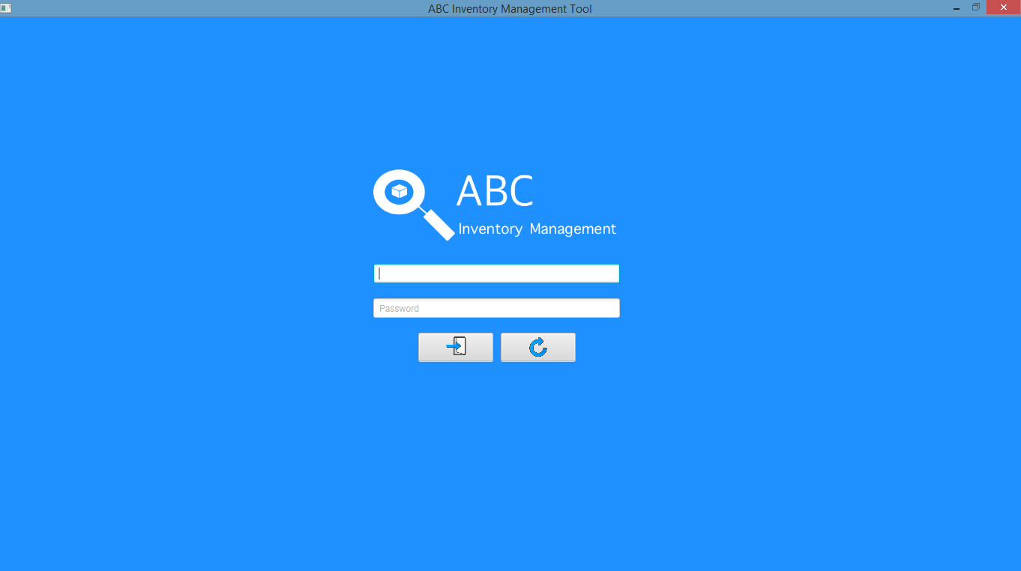

**Step 2**

Username and password are entered, and the system waits user to click on the ‘Login’ button.

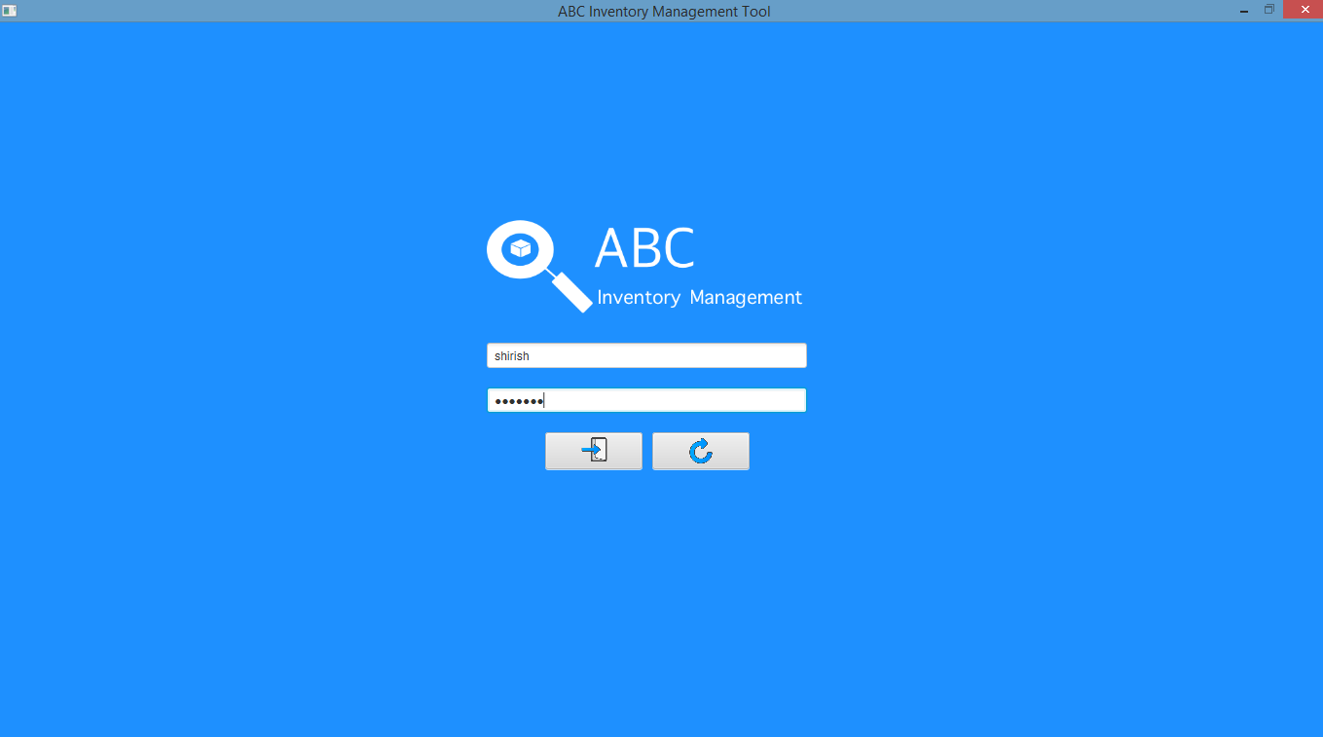

**Step 3**

After the ‘Login’ button is pressed at step 3, access is granted, and the Homepage is displayed.

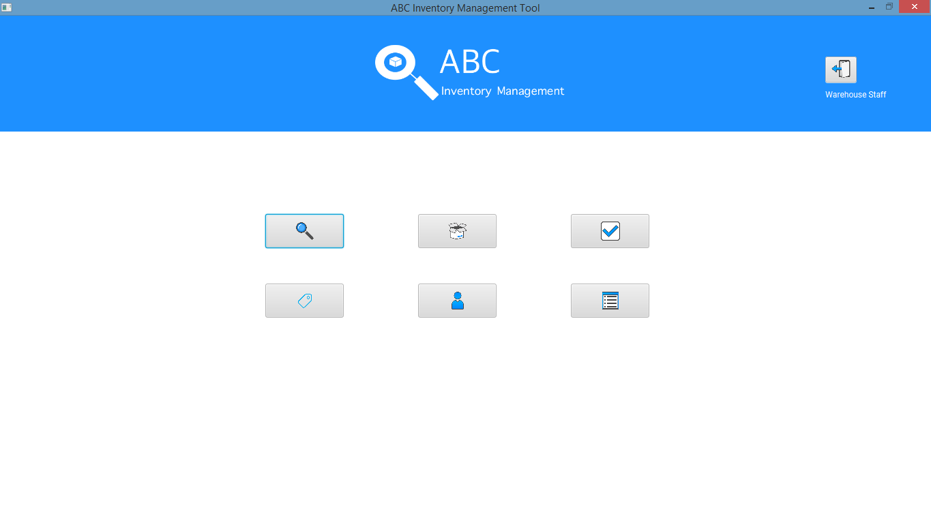

# LOS001: Logout Script

## Script Description

This script follows each step while logging out of the system to get out of the system. This script will check if each step while logging out of the system is a success. If any step fails to succeed, a bug will be reported, and the test will be conducted again.

## Testing Requirements

This test will cover the logout functionality of the system.

## Setup

* User is logged in.

## Teardown

* Other users can login into the system.

## Script Steps

|  |  |  |  |
| --- | --- | --- | --- |
| Step | Test Action | Expected Results | Pass/Fail |
| 1. |  | Homepage is displayed, and the system waits for user’s action. | Pass |
| 2. | Click on the ‘Logout’ button in the top right corner. | System displays a dialog box to confirm if user wants to log out. | Pass |
| 3. | Click on the ‘Yes’ button. | System logs the user out of the system and displays the Login page with the username and password field empty. | Pass |

### Result Screenshots

**Step 1**

Homepage is displayed, and the system waits for the user’s action.

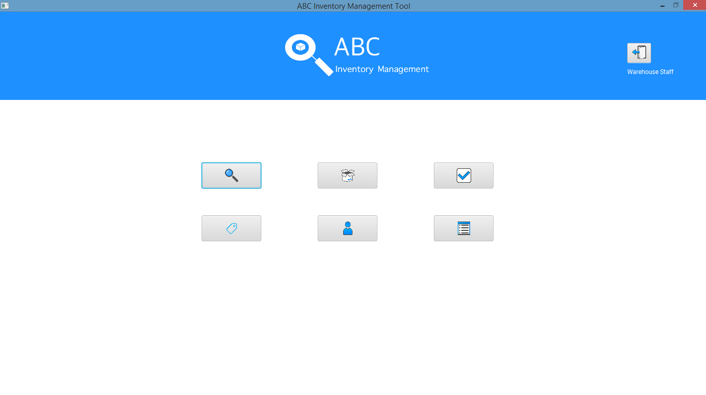

**Step 2**

After user clicks on the ‘Logout’ button in the top right corner, a dialog box is displayed to confirm if the user wants to logout.

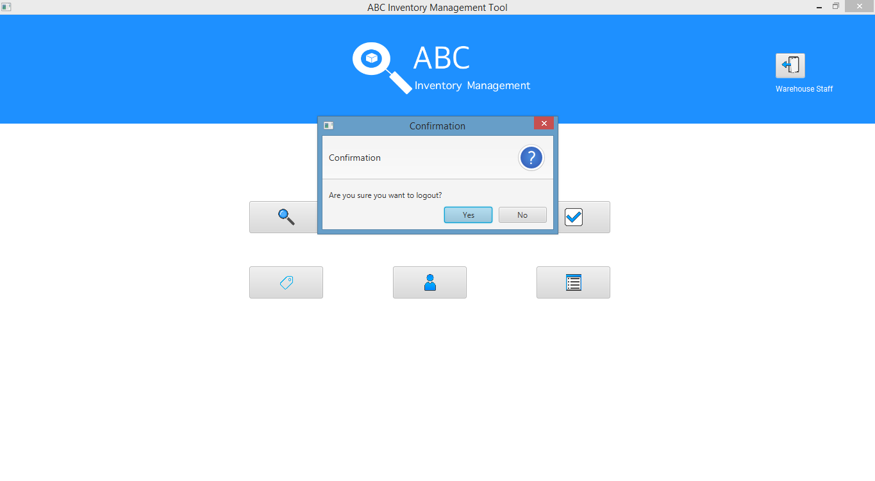

**Step 3**

User is logged out and the Login page is displayed.

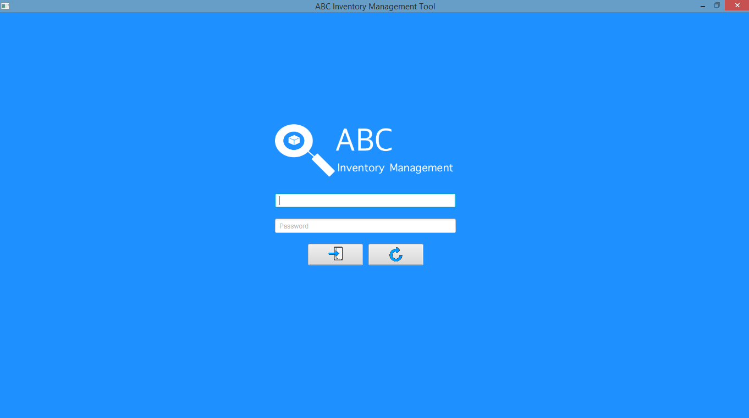

## Test Execution

|  |  |  |  |  |
| --- | --- | --- | --- | --- |
| Date/Time | Tester | Test ID | Test Phase | Status |
| 14/09/2018 | Shirish Maharjan | SM001 | Cycle 1 | Pass |